Step 1: Run the flask_app.py program in pycharm.

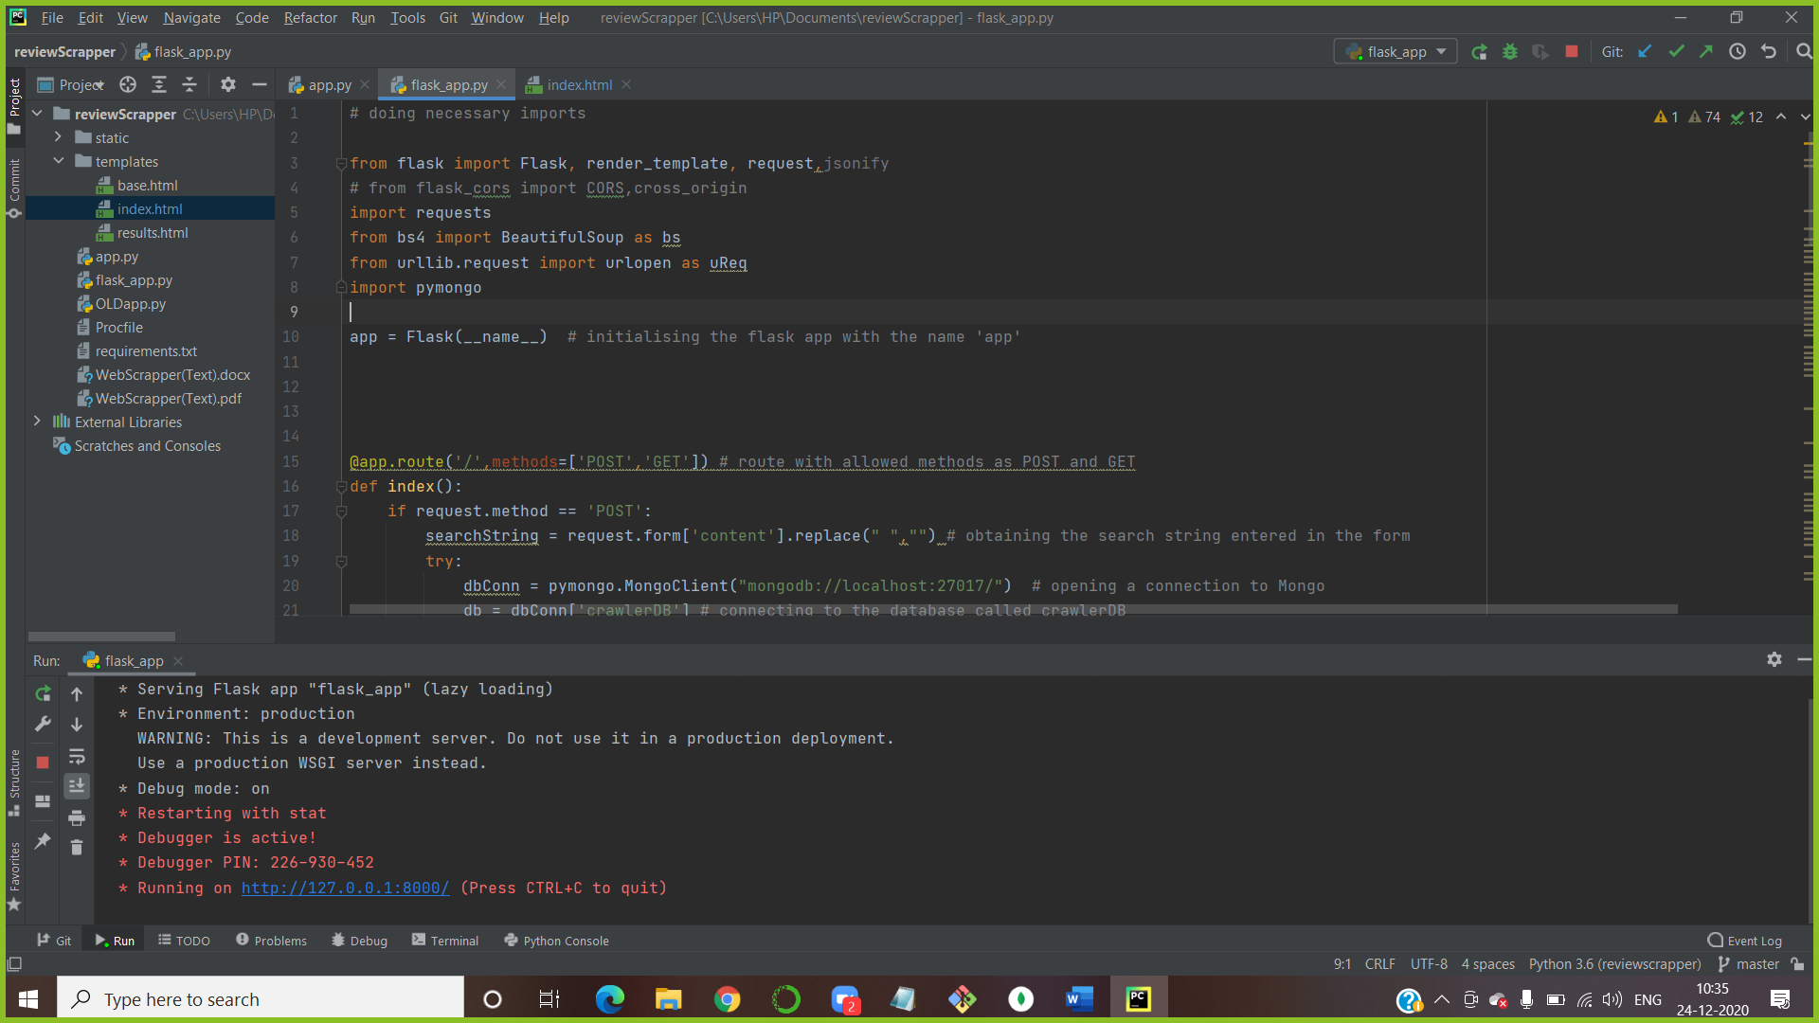

Step 2. Established a connection in MongoDB.

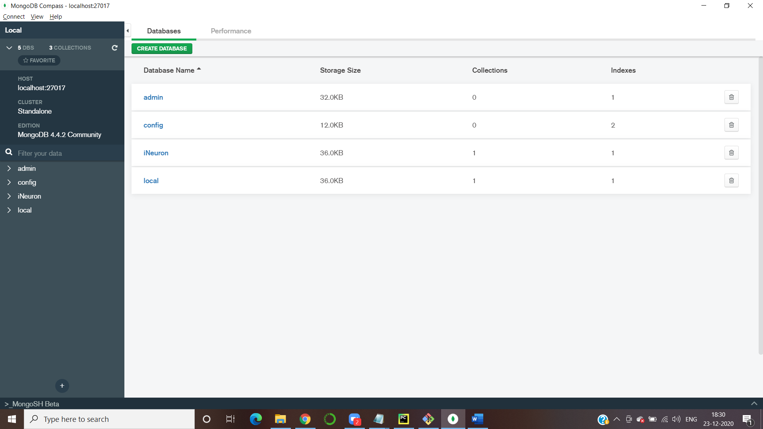

Step 3: Open local host URL

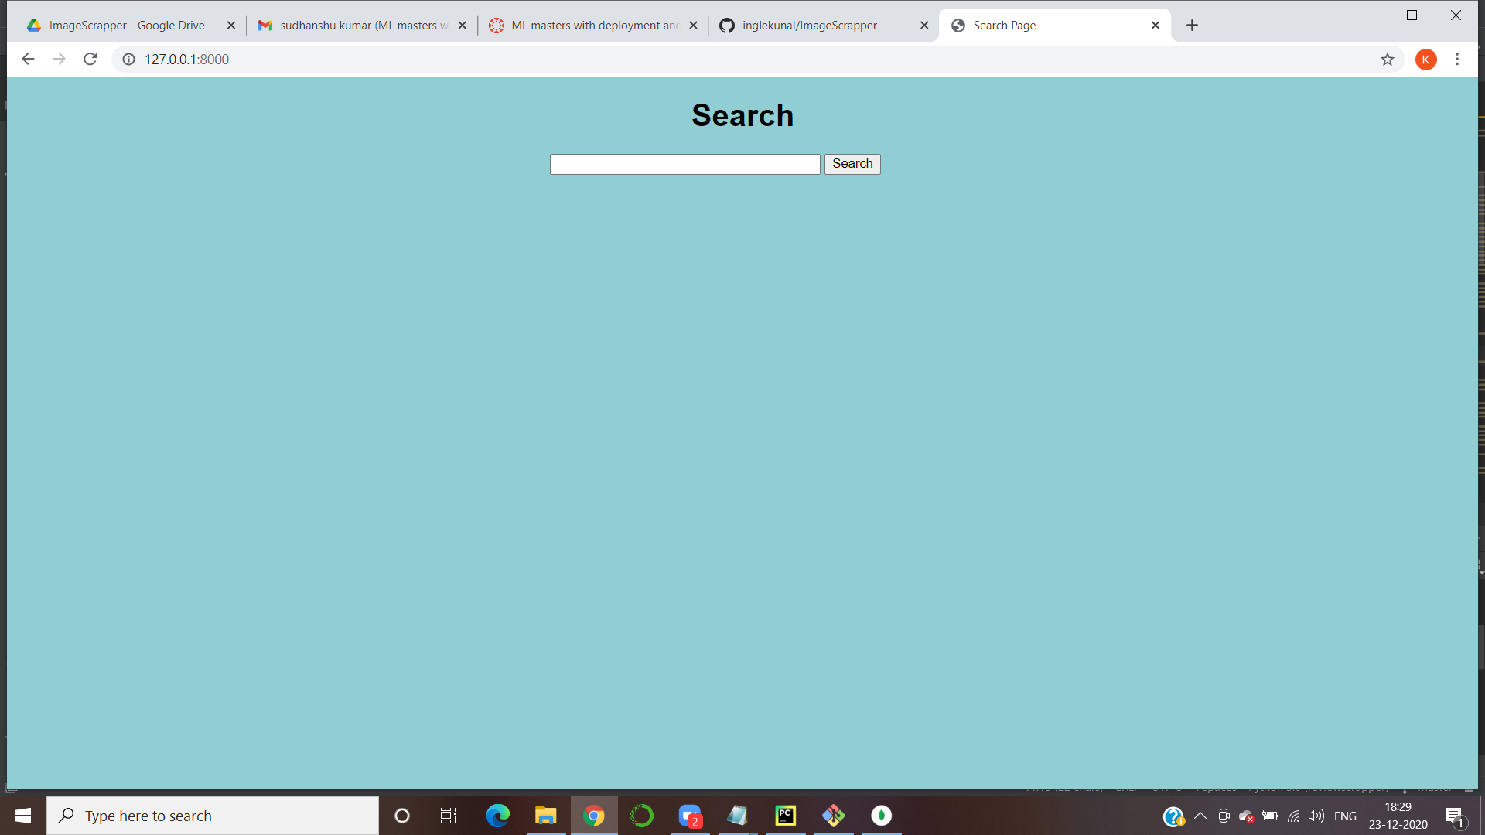

Step 4: searched for content in local host url.

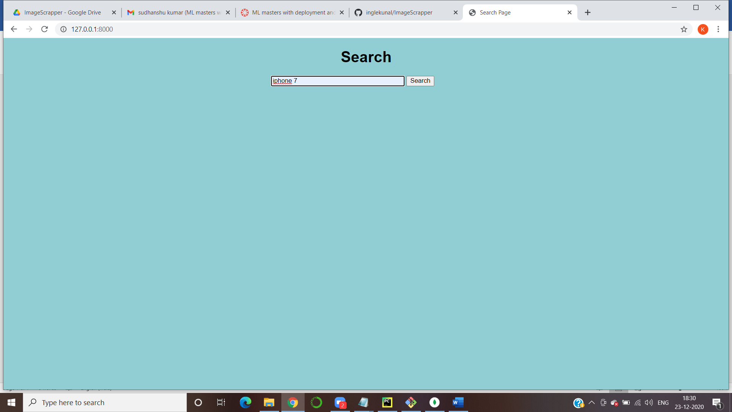

Step 5: Got review page on local host URL.

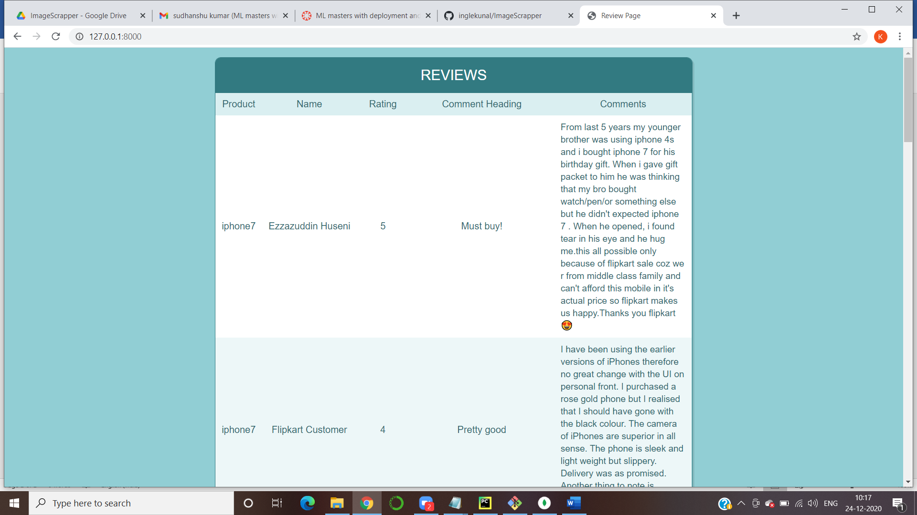

Step 6: Created crawlweDB DataBase in MongoDB.

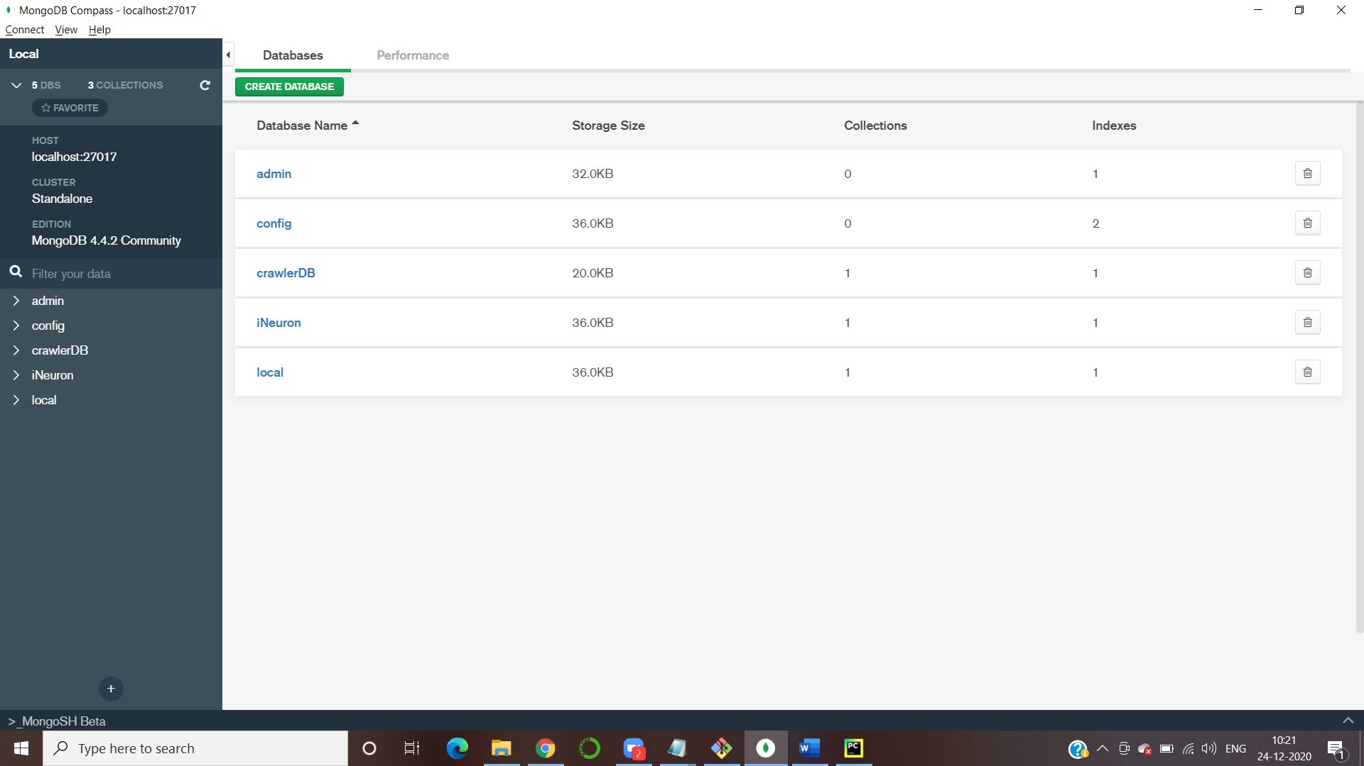

Step 7: Opened Heroku app.

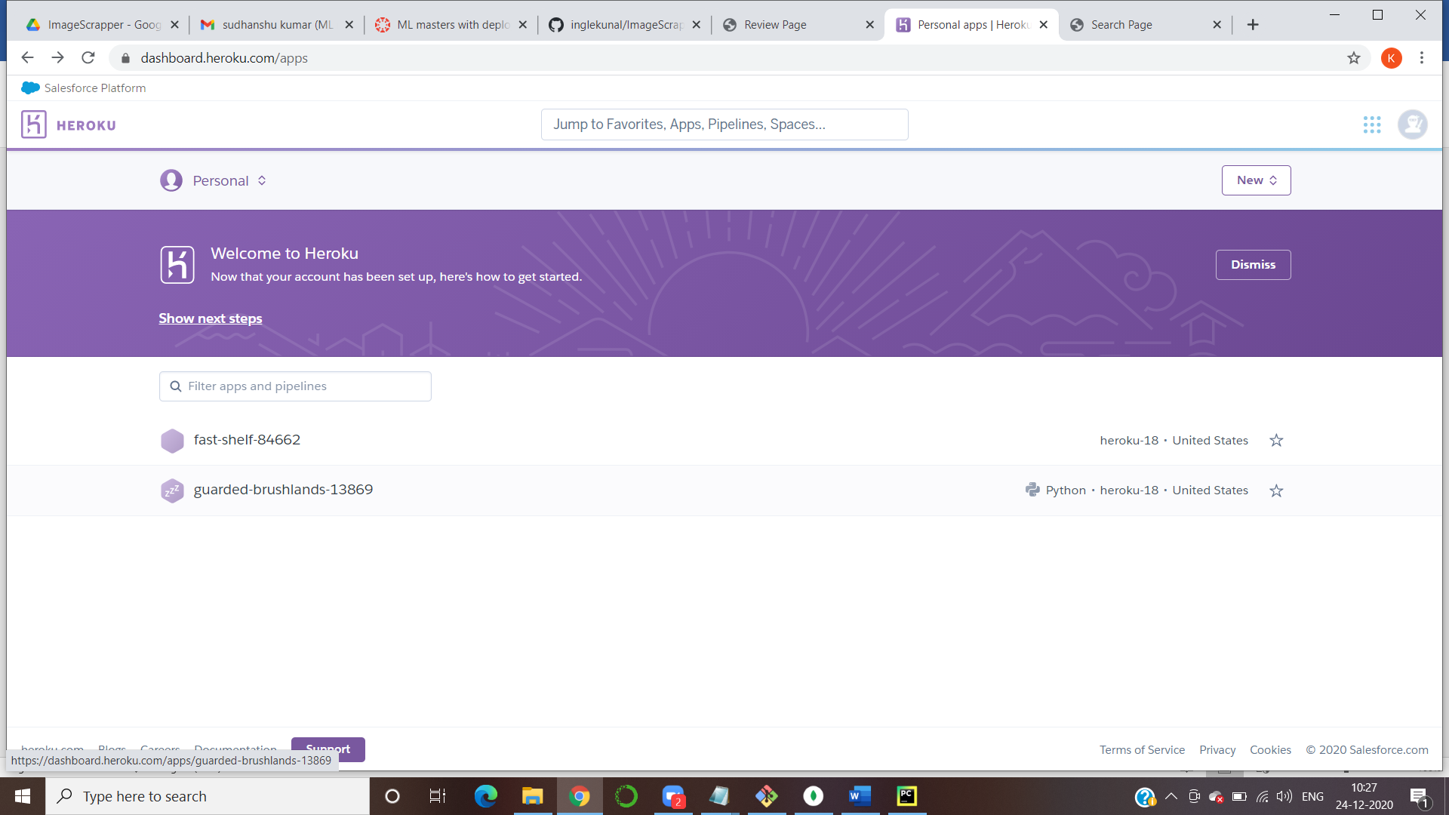

Step 8: Heroku app URL

https://guarded-brushlands-13869.herokuapp.com/

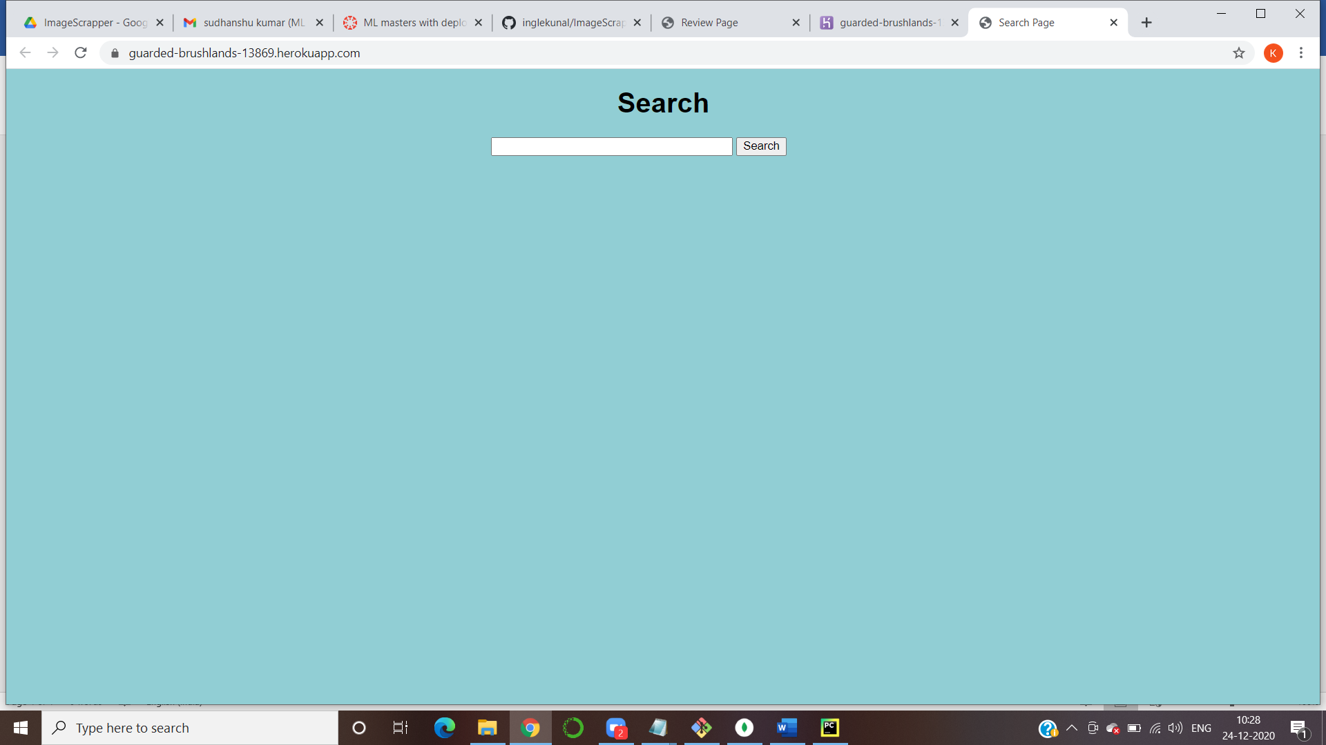

Step 9: Output of Heroku

